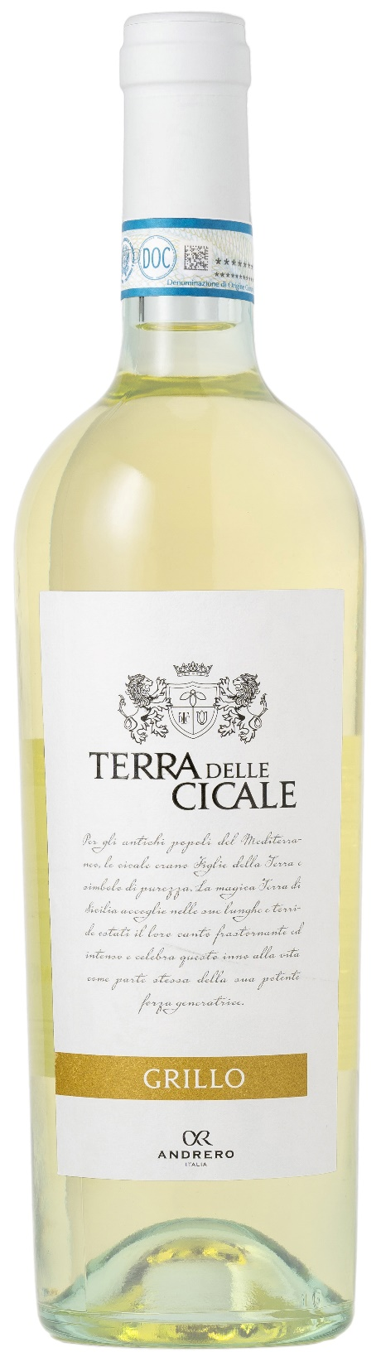
GRILLO DOP – TERRA DELLE CICALE

Grape: Grillo 100%
Alc. Vol.%: 12,5
Vintage: 2025
Residual sugar g/l: 4,5
Total acidity g/l: 6,0
Region: Sicily
Production zone: Vineyards in the Province of Trapani
Capacity: 750ml, 1500ml

CHARACTERISTICS

Vinification: In steel tanks at a controlled temperature
Aging: In steel tanks until bottling
Yield per ha: 12000kg
Colour: Light straw-yellow with greenish sparkles
Bouquet: Elegant notes of tropical fruits
Flavour: Smooth, dry, fresh and pleasantly tasty

SERVING SUGGESTIONS

Best enjoyed with fish dishes, seafood and white meat.
Serving temperature 8 °C
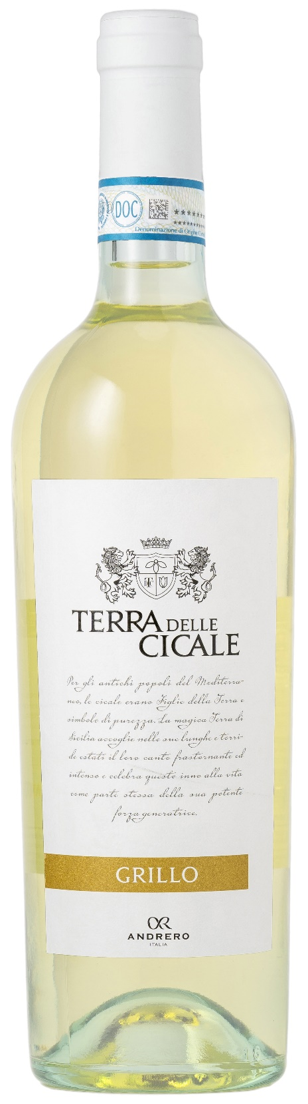
TECHNICAL INFORMATION / PALLETIZING

Size 750ml:
Article Nr. V11005A
GTIN-13 bottle 8017868001065
GTIN-13 carton 8017868001096
Closure Cork
Bottles / carton 6 bottles
Pallet size 80x120cm
Cartons/layer 21
Cartons/pallet 105
Kg/carton 7,8
Kg/pallet 845

Size 1500ml:
Article Nr. V11004B
GTIN-13 bottle 8017868001072
GTIN-13 carton 8017868001485
Closure Screwcap
Bottles / carton 6 bottles
Pallet size 80x120cm
Cartons/layer 14
Cartons/pallet 56
Kg/carton 13,5
Kg/pallet 780

Contains sulphites
GMO Free
Revisione 01. 14.05.2026

